**Object Oriented Programming Lab**

**Fall’20**

**Department of Computer Science**

|  |  |
| --- | --- |
| **STUDENT NAME** | Taimoor manzoor |
| **STUDENT ID** | Sp20-bscs-0021 |
| **SECTION** | AM |
| **ASSIGNMENT NO.** | 1 |
| **DUE DATE** | 2/10/2020 |
| **SUBMITTED ON** | 1/10/2020 |

***Mohammad Ali Jinnah University***

**Object Oriented Programming Lab**

**Fall’20**

**Question 1/Task 1:**

**Answer:**

Attach pictures of your work. Also, write the description.

In this task we learn that how to run and compiler the program in the command prompt and also show that the code and also that how to generate the file after compiling and running.

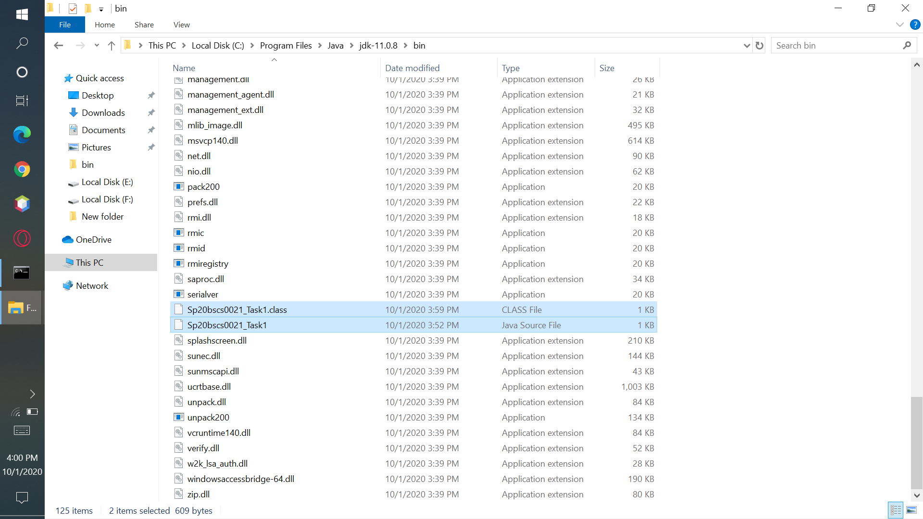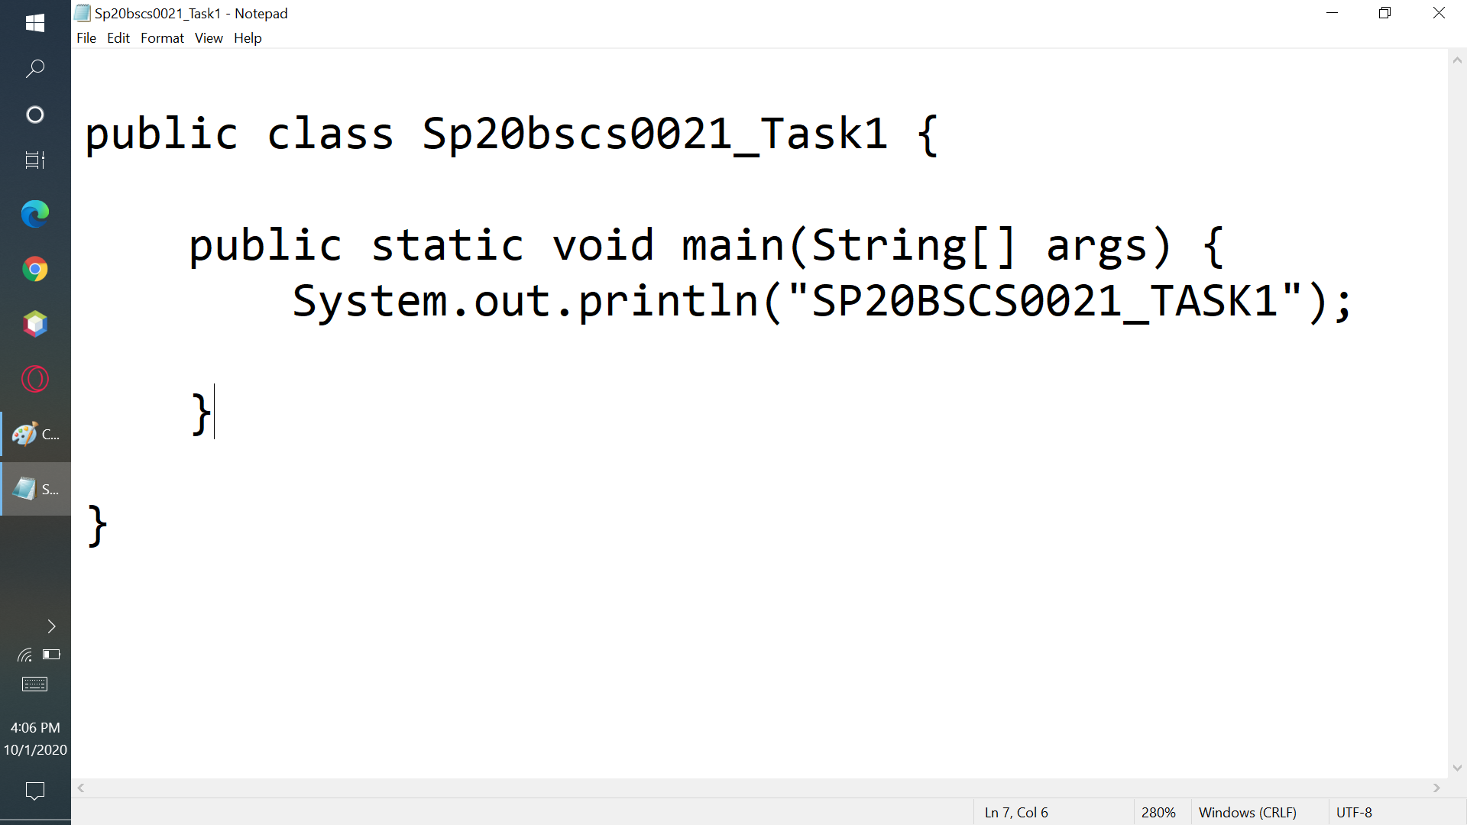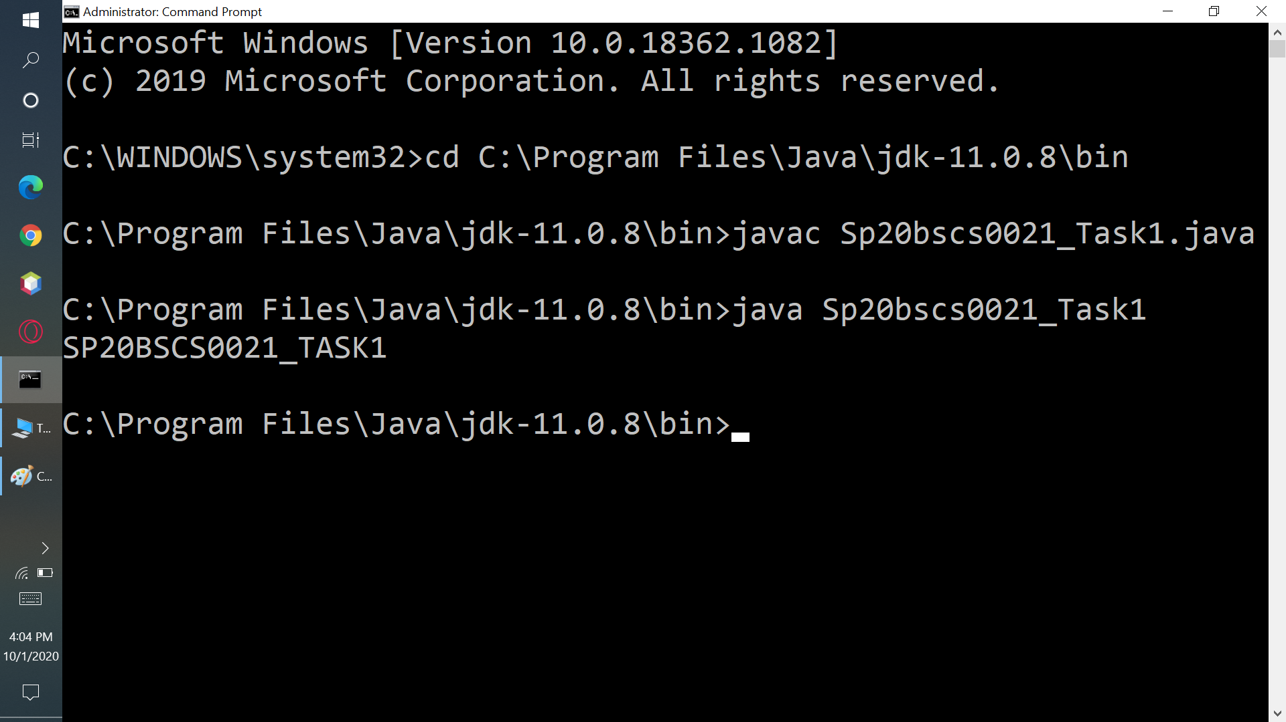

**Question 2/Task 2:**

**Answer:**

Attach pictures of your work. Also, write the description. In this program we learn that how to take input by the user .In the array

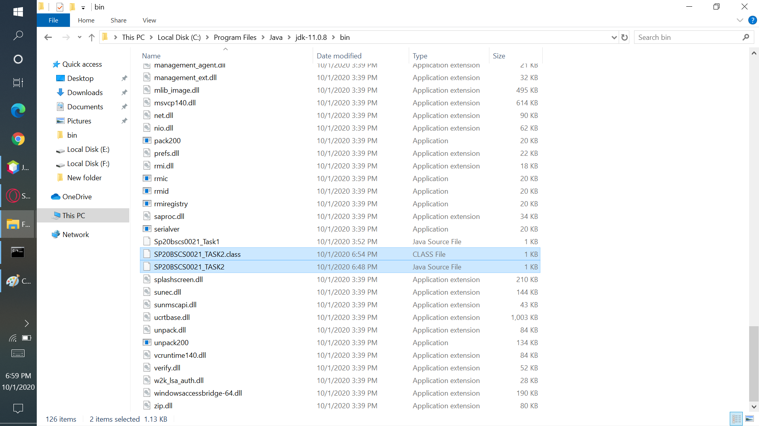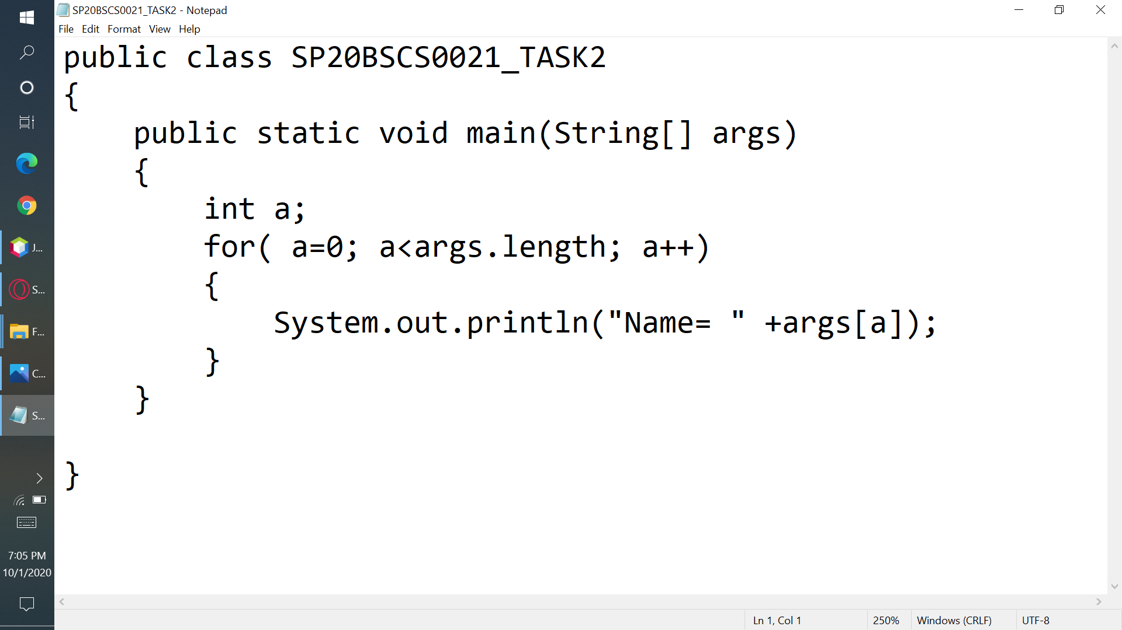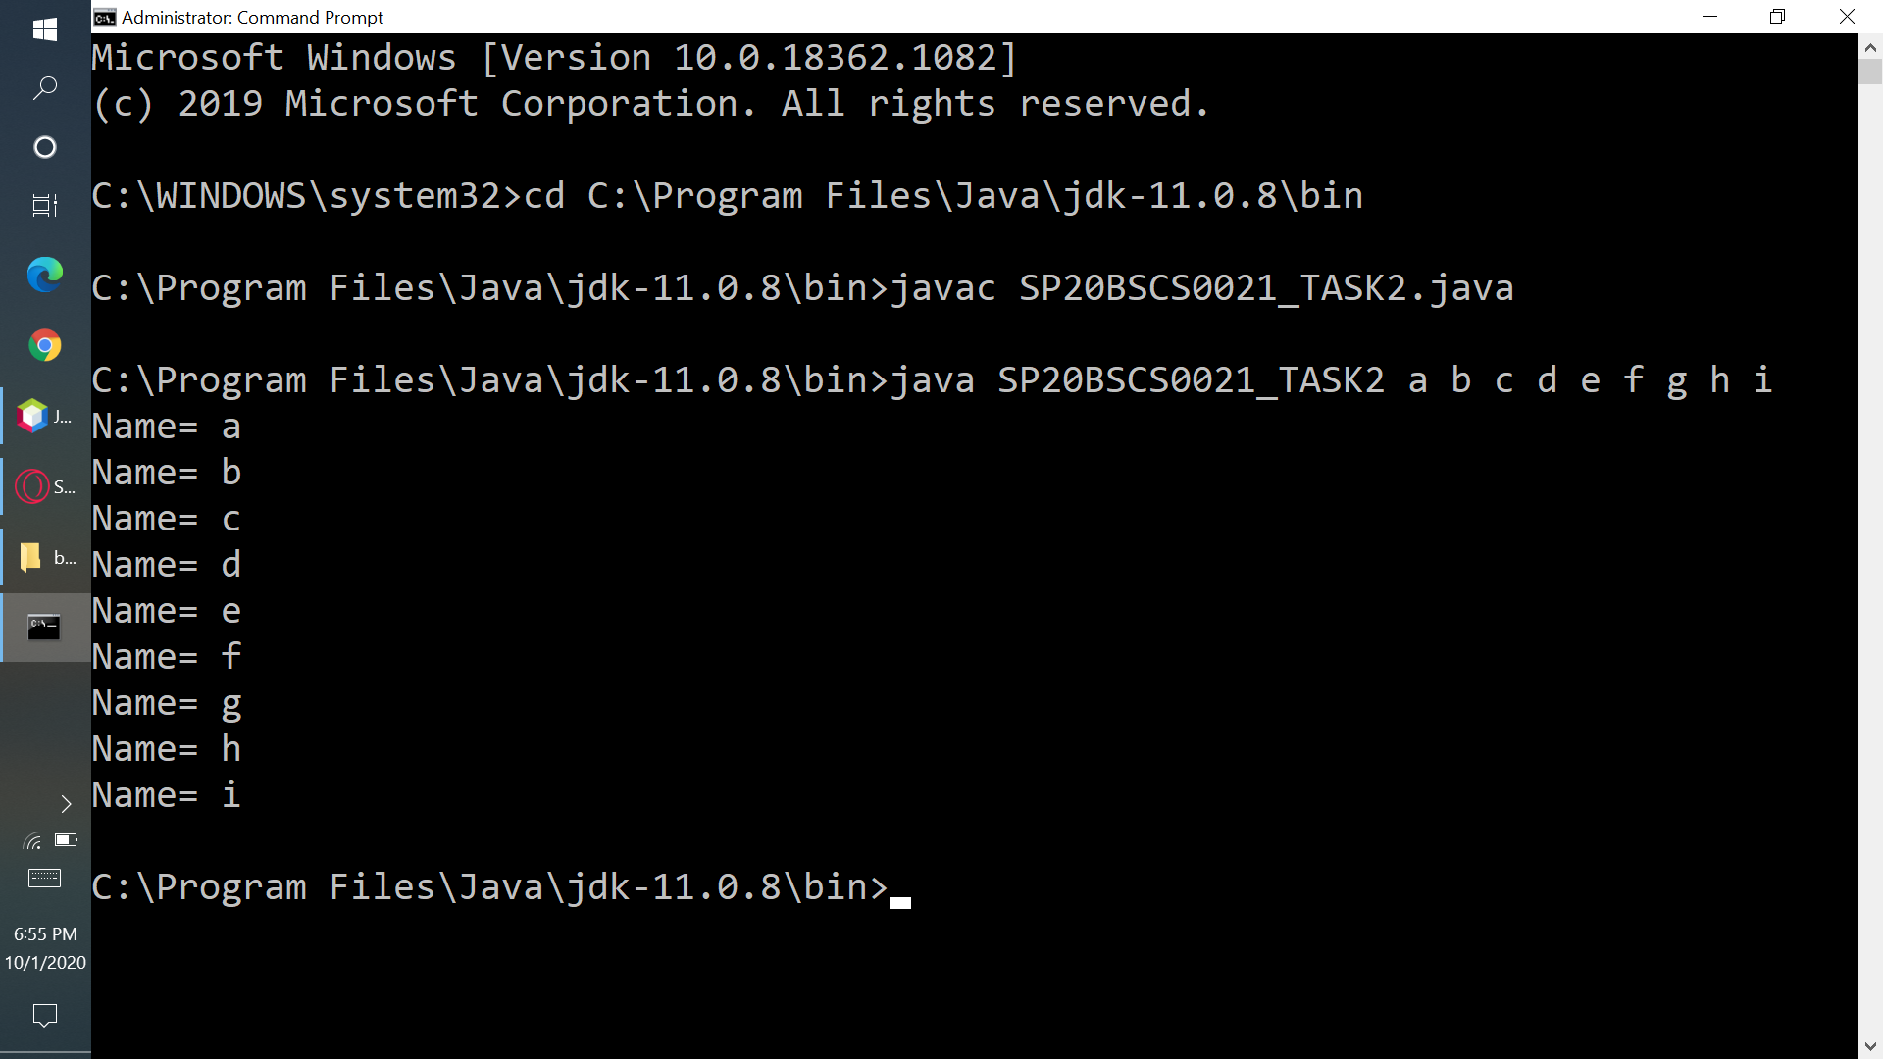

***Mohammad Ali Jinnah University***